econometric model in forecasting



What is a forecast?

• “Anything can be forecast, but not everything can be predicted.”

Predict – implies inference from laws of nature, whereas

Forecast – more probabilistic

Etymology of “forecast”

Fore – is clear, denoting “in front” or “in advance”

Cast – dice, lots, spells, horoscopes are all cast

• A forecast is any statement about the future

• There are two basic methods of forecasting

A “crystal ball” that can see the future,

Extrapolate from present information

We adopt a Forecasting Rule:

A systematic operational procedure for making statements about future events.



What is Econometric forecasting?

“An econometric model is one of the tools economists use to forecast future developments in the economy. In the simplest terms, econometricians measure past relationships among such variables as consumer spending, household income, tax rates, [interest rates](https://www.econlib.org/library/Enc/InterestRates.html), employment, and the like, and then try to forecast how changes in some variables will affect the future course of others”.

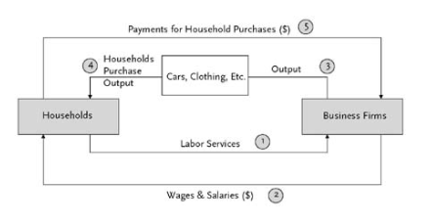

Methods of Econometric Forecasting:

1. Guessing, rules of thumb,

2. Extrapolation

3. Leading indicators

4. Surveys

5. Time series models

6. Econometric forecasting models

Importance of Econometric models

1. These models provide the tools that can be used for extracting useful information from the available data related to important economic policies.
2. Without evidence, economic theories are abstract and might have no bearing on reality (even if they are completely rigorous).
3. Students who gain expertise in econometrics will also find that they enhance their job prospects.
4. Students who graduated in econometrics can lead to employment as an economist for government agencies, investment banks, research institutes or international organizations.

Common econometric models are:

* [Linear regression](https://en.wikipedia.org/wiki/Linear_regression)
* [Generalized linear models](https://en.wikipedia.org/wiki/Generalized_linear_model)
* [Probit](https://en.wikipedia.org/wiki/Probit)
* [Logit](https://en.wikipedia.org/wiki/Logit)
* [Tobit](https://en.wikipedia.org/wiki/Tobit_model)
* [ARIMA](https://en.wikipedia.org/wiki/ARIMA)
* [Vector Auto-regression](https://en.wikipedia.org/wiki/Vector_Autoregression)
* [Co-integration](https://en.wikipedia.org/wiki/Cointegration)
* [Hazard](https://en.wikipedia.org/wiki/Hazard)

**Illustration:**

Specification of a Simple Econometric Model for the Keynesian Theory of Consumption



Where,

Y = consumption expenditure; X = income; α, β = parameters

By including the random variable ε, known as the error

ε, the error term, is due to:

1) Omission of the influence of innumerable random events.  
2) Errors in the measurement.  
3) Indeterminate human behavior

In order to determine the numerical values ​​of the parameters, the choice of data is very important. These could be:

1) Time series  
2) Cross-sectional data  
3) Data panel

Econometric forecasting on Linear Regression:

What is linear regression?

The linear regression model has a dependent variable(Y) that is a continuous variable, while the independent variables(X) can take any form (continuous, discrete, or indicator variables).  A simple linear regression model has only one independent variable, while a multiple linear regression model has two or more independent variables.  The linear regression is typically estimated using OLS (ordinary least squares). Examples include studying the effect of education on income; or the effect of recession on stock returns

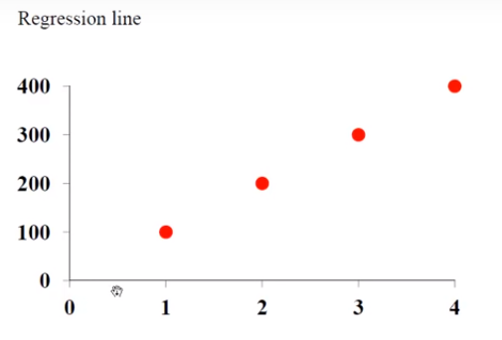

X= number of credit cards

Y= dollar spent

The linear regression model describe how the dependent variable is related to the independent variable and the error term

y= xβ+u

y-dependent variable, x – independent variable, β-intercept, u-error

regression error:

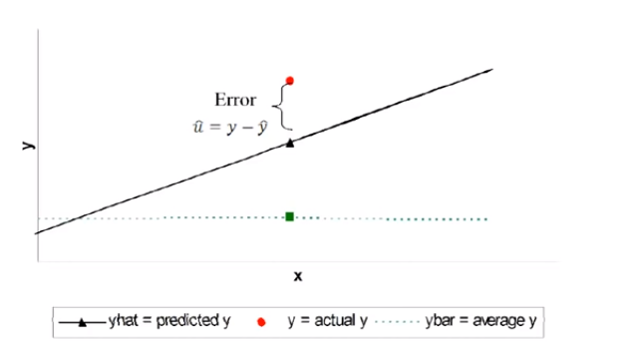

error means difference between actual value and predicted values of the dependent variables

OLS method:

The ordinary least square method is used to calculate the coefficients so that the errors are as small as possible.

We minimize the sum of squared residuals:

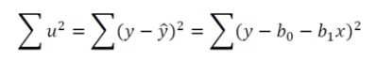

Goodness of fit:

What is R-squared?

• The coefficient of determination (R-squared )provides a measure of the goodness of fit for the estimated regression equation



• Values of R-squared to 1 indicate perfect fit, values close to zero indicate poor fit

• R-squared that is greator than 0.25 is considered good in the economics field

•R-squared interpretation: if R-squared = 0.8 then 80% of the variation is explained by the regression and the rest is due to error, so, we have a good fit